Assignment 1

Script:

#Installing httpd package

yum install httpd -y

#starting httpd service

systemctl start httpd

#enable httpd service

systemctl enable httpd

#To create index.html file go to below path

cd /var/www/html

#Creating index.html

echo "Hello all, This is 1st job" > index.html

#Change file permission to make it executable

chmod -R 777 index.html

#To check web server content using curl command with public ip address

curl 18.234.207.41

**Console output with curl command:**

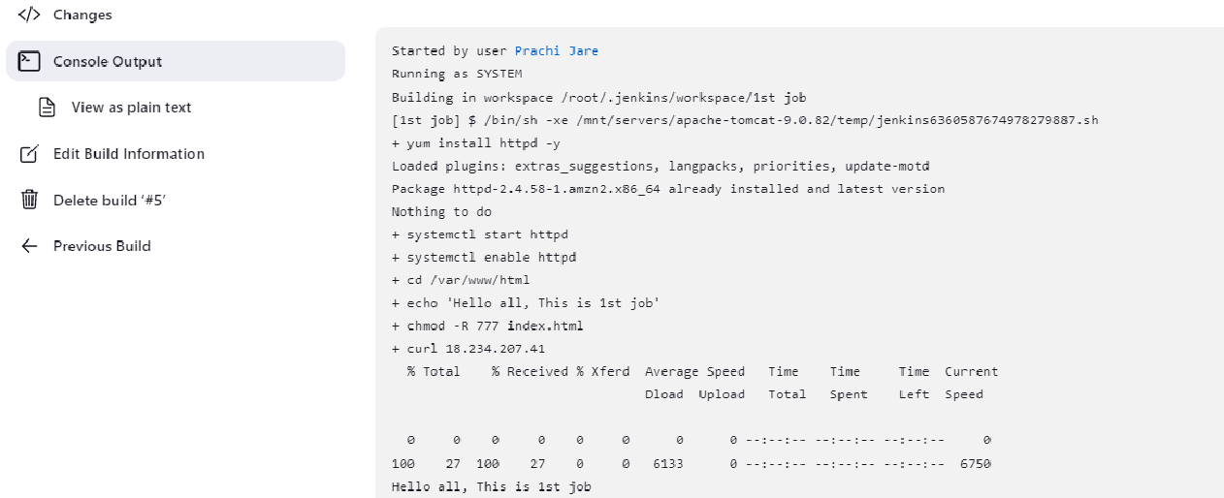

**Console output without curl command:**

